**PRF NO: 1100028003 DATED 13.01.2017**

**DCS UPGRADATION,YOKOGAWA,CENTUM VP**

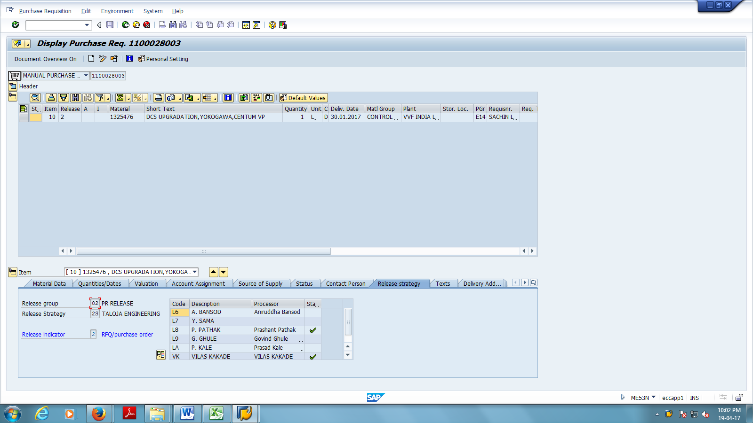

**PRF NO: 1100028004 DATED 13.01.2017**

DCS UPGRADATION,SCHNEIDER,FOX EVO

